STEWART’S MELVILLE COLLEGE CLUB

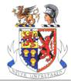

Office Bearers

President: Ken Russell

Vice President: to be confirmed and elected

Honorary Secretary: John Hughes

Honorary Treasurer: Rob Kernohan

Council Members

Bert Barclay

Alasdair Seale

Chris Anderson

John Archer

David Kyles

